Step 1 https://webmail.totalcomputingsolutions.net
For web mail log into or go to redknightsmc.com/member/email/emaillogin
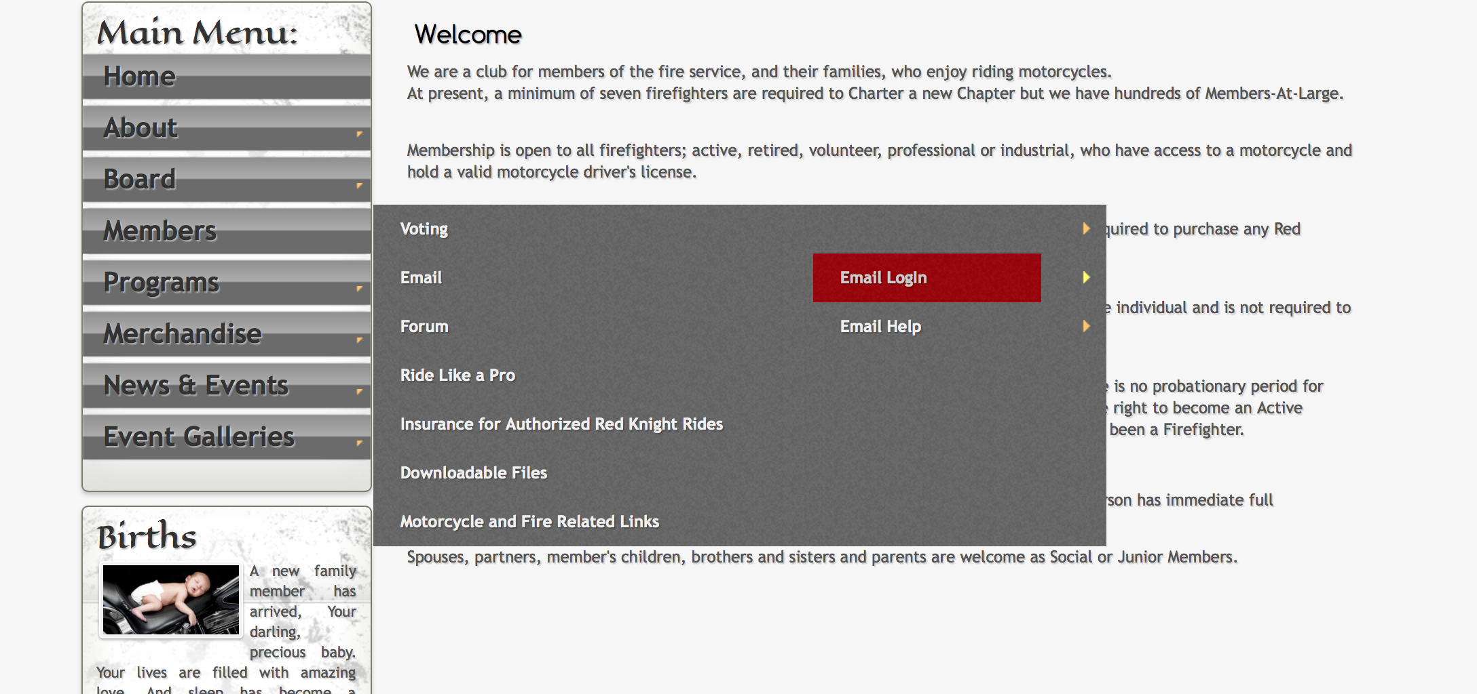
Step 2 Enter the Chapter redknightsmc.com email address that was given to you by your Regional Director then enter the password that was also given to you by the Regional Director. (Your browser may give you the option of memorizing your user name and password.) You may change your password at any time. Keep it in a safe place because the Webmaster can't access your changed password he/she can only reset the password. When there is a change in the leadership of the Chapter, please change the password.
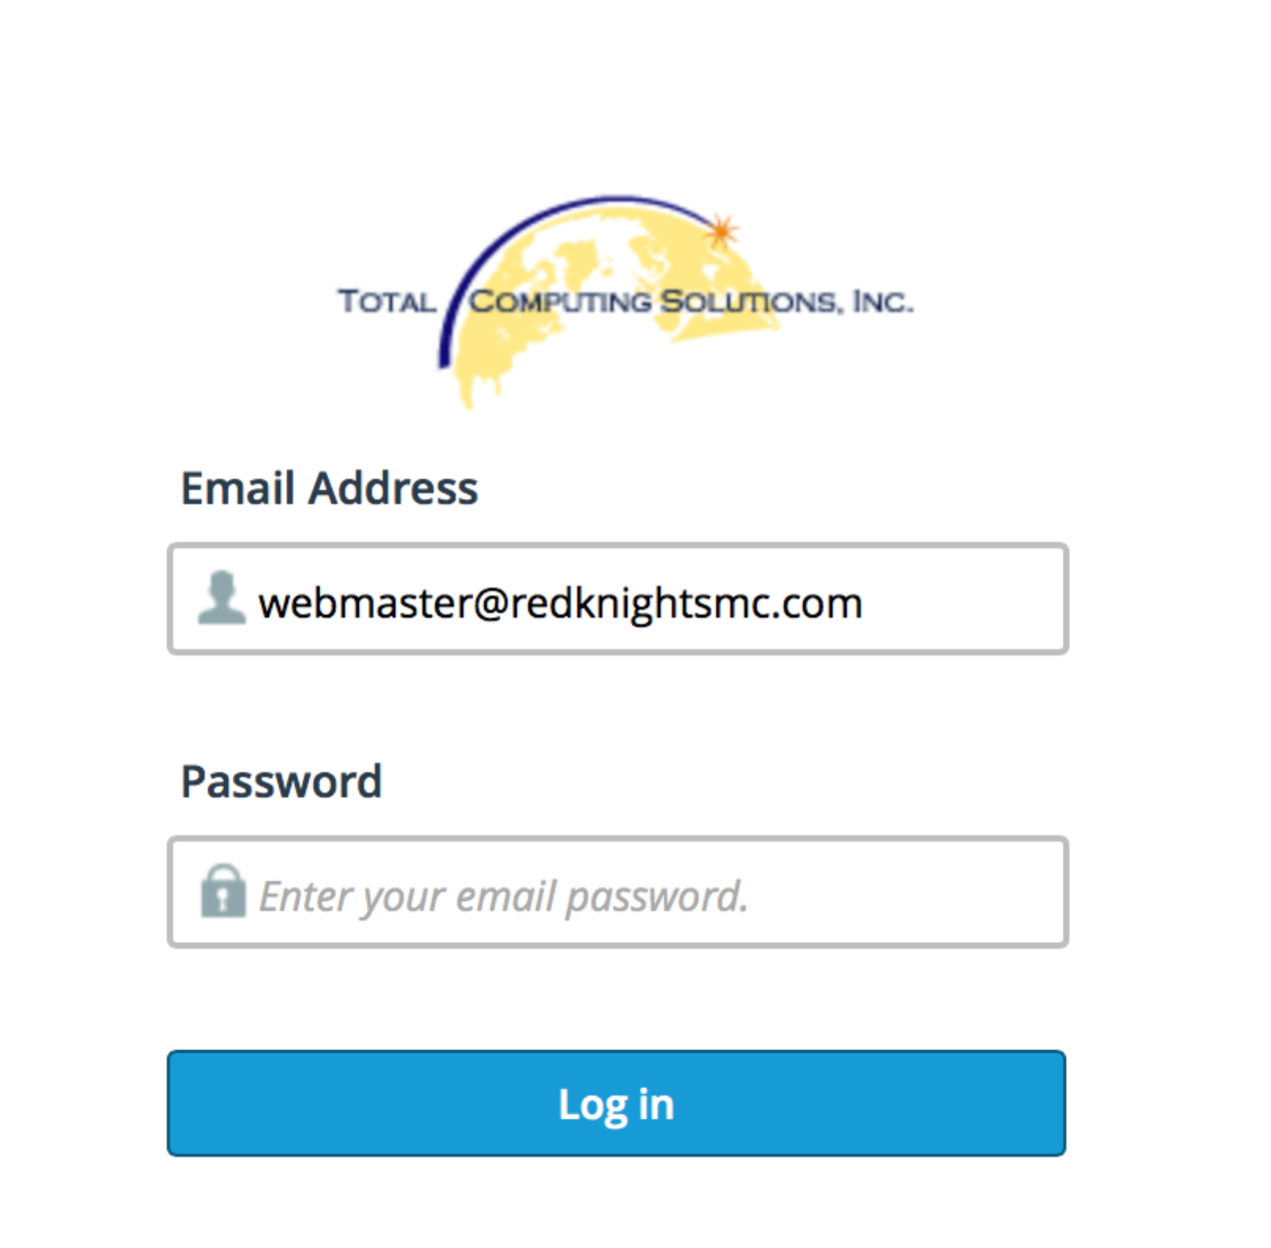

Step 3 Click on Access your WebMail
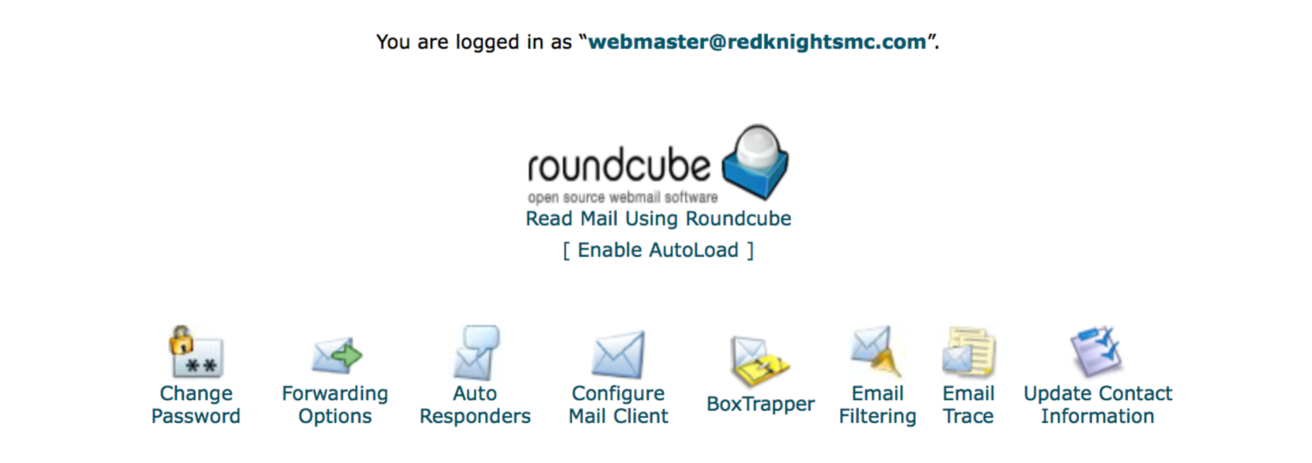

Step 4 Select roundcube to read your webmail.
This is where you can see your WebMail and you can compose mail and send it using your redknightsmc.com email address.
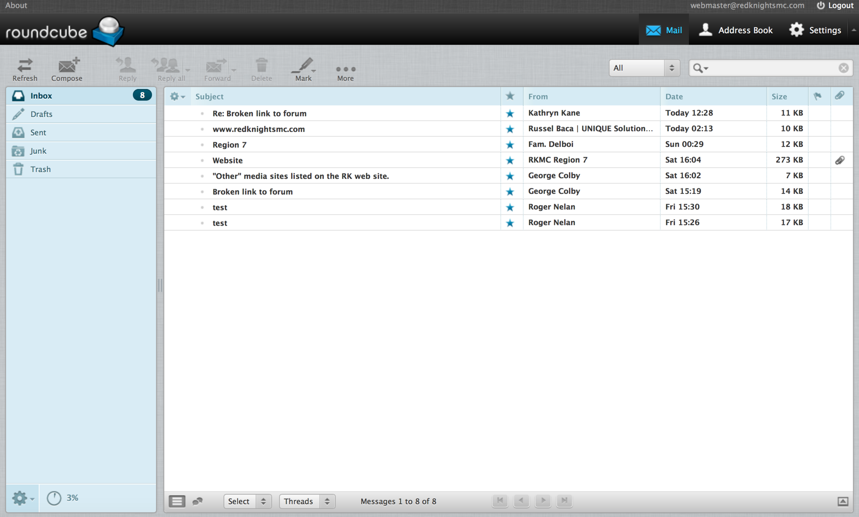

Step 5 Forwarders can be used to send your Redknightsmc.com emails to your personal email, see below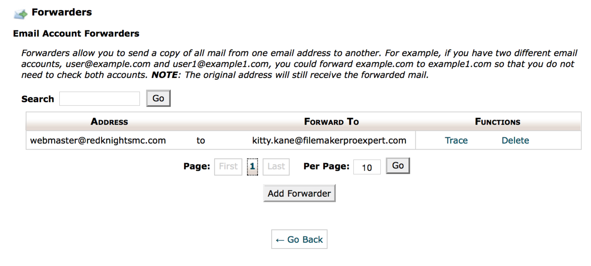
Step 6 If you already have your email for redknightsmc.com set up and but just need to update the setting for the new email configuration, go to you email settings and make the following changes. Update your outgoing SMTP server to earth.totalcomputingsolutions.net Please check your ports are using the correct port number.
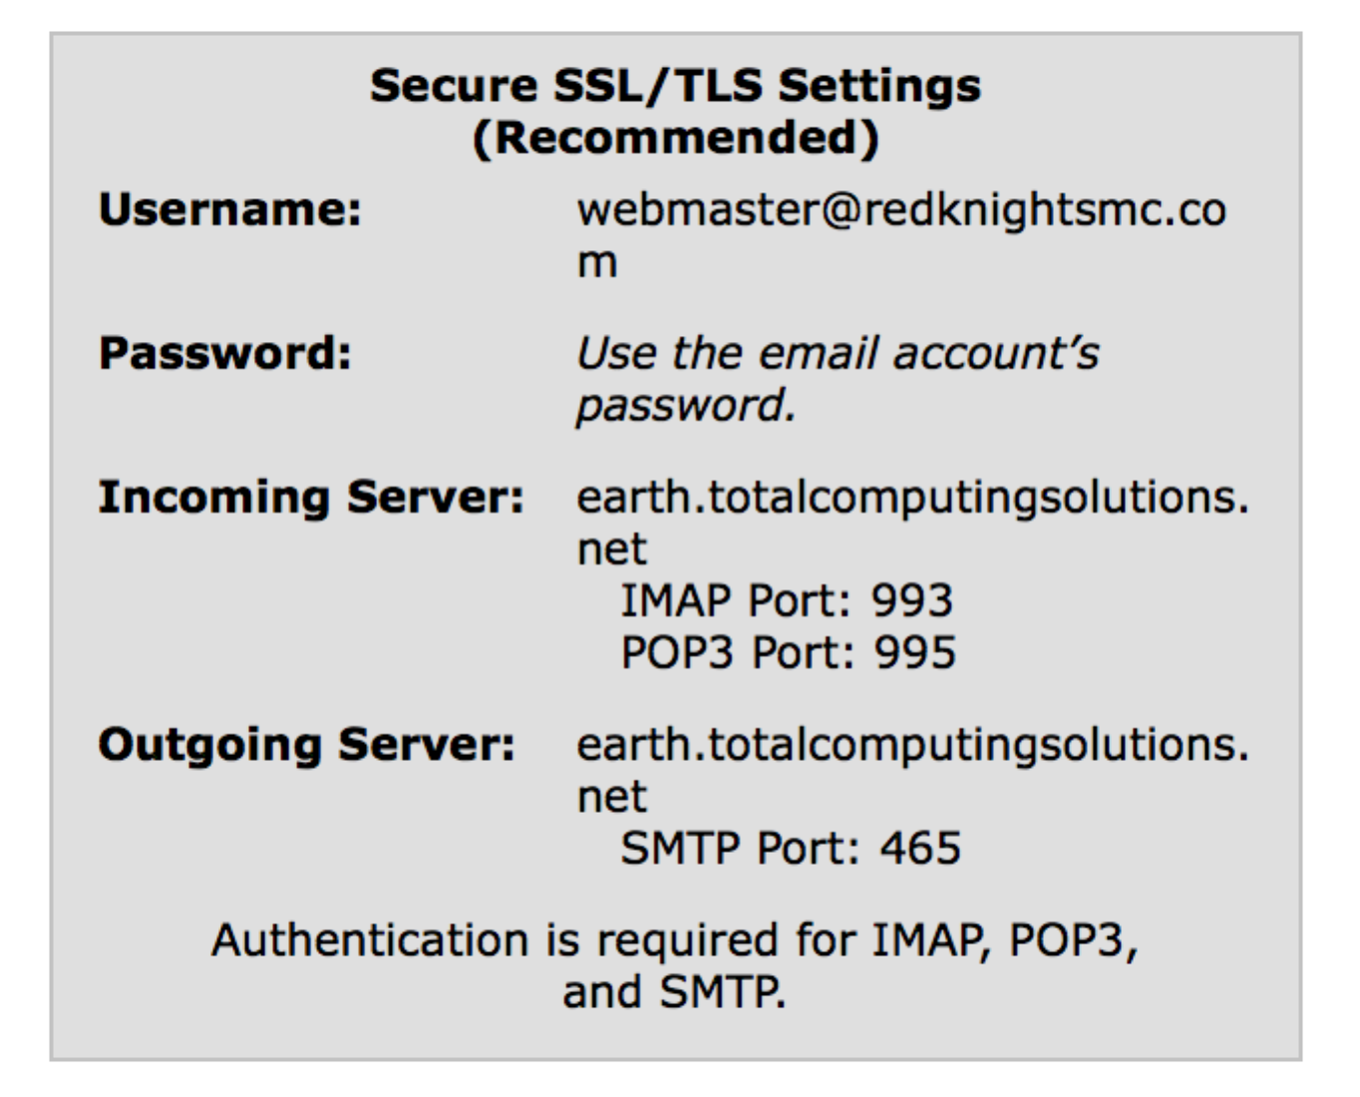

Step 7 (Use this feature only for first time setup.) Configure Mail Client. If you are using an email application, or would like to set up your cell phone to send and receive emails. Use this area for configurations and/or setup.
